**Design best practices**

**Introduction**

The explosion of data analytics has opened new opportunities for organizations to gain insights into their data and make data-driven decisions. With tools like Microsoft Power BI, even non-technical users can build and share dashboards and reports. However, it's crucial to ensure that these reports are accessible to everyone, including those with disabilities. By following best practices in designing accessible reports, you're enabling more people to access, understand, and use the data.

**Best practices for designing accessible Power BI reports**

**Choose accessible color schemes**

One of the first considerations for designing accessible reports is color selection. Avoid colors that are difficult to differentiate for individuals with color blindness or low vision. Instead, use a color-blind-friendly palette and ensure that colors used in graphs, charts, and other visual elements have a high contrast ratio against their backgrounds for better readability and accessibility. Use tools such as the *WCAG Color Contrast Checker* to check color contrast and ensure visual clarity. Additionally, providing data in alternative formats, like patterns or textures, can enhance comprehension for users with color blindness. For example, you can use markers instead of relying solely on color to convey information to ensure users with color vision deficiencies can distinguish between different data series.

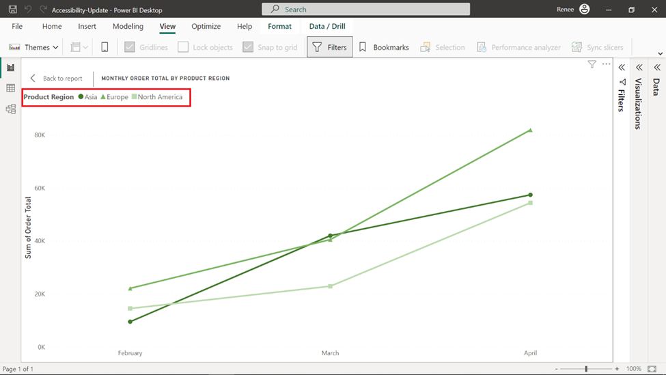

**Use clear typography**

Fonts should be legible and easily distinguishable. Stick to sans-serif fonts, such as Arial or Verdana, and avoid overly decorative fonts. Ensure text size is large enough to be easily read by those with low vision. Avoid using color alone to convey information—instead, use patterns, labels, or additional text to provide context.

**Make interactive elements accessible**

Power BI offers several interactive features, such as slicers, buttons, and drill-through options. Ensure that these elements can be accessed, operated, and navigated with a keyboard. Keyboard navigation is a critical aspect of report accessibility, as many users rely solely on keyboard input. Setting a logical tab order ensures that users can navigate through the report elements systematically, enhancing the overall user experience. Also, make sure to provide descriptive text or tooltips for the interactive elements. Screen readers should be able to read the text descriptions, allowing users with visual impairments to interact with your report.

**Provide descriptions and alt text for images**

When including images, charts, or other visual elements in your report, always provide descriptive alt text. This text will be read by screen readers, helping users with visual impairments to understand the content. Likewise, enhance report comprehension by using clear and descriptive titles for visuals and report pages. Keep descriptions concise yet informative, and avoid using technical jargon.

**Test accessibility features**

To ensure your reports are fully accessible, test them using screen readers or other assistive technologies, simulated low-vision scenarios, browser add-ons, and squint tests. Make sure to test your report with multiple tools, as some may interpret information differently. Also, consider soliciting feedback from users with disabilities to improve your report’s accessibility.

**Create accessible data tables**

When using data tables in your report, ensure they're designed with accessibility in mind. Use header rows and columns to label data and provide clear, concise captions to explain the table's content. Avoid using merged cells, as they can be confusing for screen readers. Instead, use separate cells and label them appropriately. Additionally, offer a screen-reader-friendly data table to present data in an alternative format.

**Use inclusive language**

Avoid language that could be offensive or exclusionary. Language should be clear, concise, and free of technical jargon. Remember, your goal is to make your reports as understandable and inclusive as possible.

**Provide multiple formats**

Not everyone may be able to access or interact with your Power BI report. Therefore, consider providing your report in multiple formats, such as PDFs or Excel files. Make sure these alternative formats are also accessible. For instance, use tagged PDFs that support screen readers and ensure Excel files are properly structured with headings and alt text for images. The image that follows shows how Power BI enables users to view data in a visual in tabular format using the **Show Data** option for visuals. This is beneficial for those who have difficulty interpreting visual data or prefer viewing data in a more structured, tabular format. It also provides a textual representation of the visual data that can be read out by screen readers, benefiting visually impaired users.

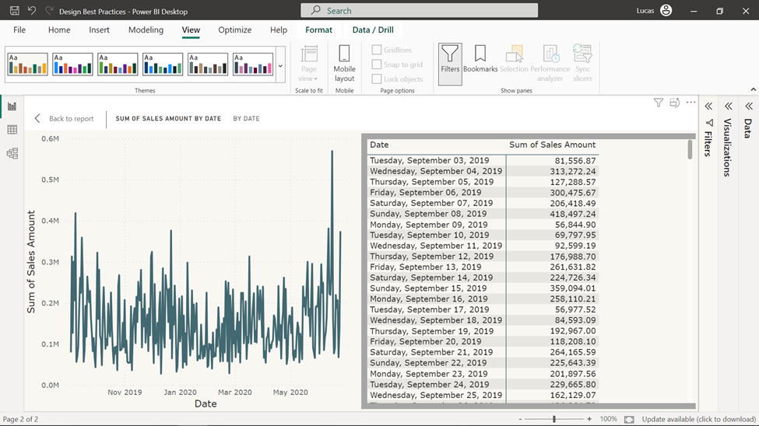

**Consider cognitive accessibility**

Keep in mind that some users may have cognitive disabilities that affect their ability to process information. Simplify complex ideas, break information into chunks, and use bulleted or numbered lists to make your report easier to read. Additionally, consider providing a summary or executive brief for users who may find it challenging to process a lengthy report.

**Train your team**

It's essential that everyone involved in creating reports is aware of the importance of accessibility. Provide training and resources on best practices for creating accessible reports. Regularly review and update these resources to ensure your team is up-to-date with the latest accessibility standards.

**Report accessibility checklist**

Power BI offers a handy checklist you can use when creating your reports to help ensure they are accessible to a wide audience before you publish them.

**All visuals**

* Ensure color contrast between the title, axis label, and data label text and the background is at least 4.5:1.
* Avoid using color as the only means of conveying information. Use text or icons to supplement or replace the color.
* Replace unnecessary jargon or acronyms.
* Ensure alt text is added to all non-decorative visuals on the page
* Check that your report page works for users with color vision deficiency.
* Use appropriate header sizes corresponding to the hierarchy of information.

**Slicers**

* If you have a collection of several slicers on your report pages, ensure your design is consistent across pages. Use the same font, colors, and spatial position as much as possible.

**Textbox**

* Ensure color contrast between font and background is at least 4.5:1.
* Make sure to put text contents in the alt text box so screen readers can read them.

**Visual interactions**

* Is key information only accessible through an interaction? If so, rearrange your visuals so they're pre-filtered to make the important conclusion more obvious.
* Are you using bookmarks for navigation? Try navigating your report with a keyboard to ensure the experience is acceptable for keyboard-only users.

**Sort order**

* Have you purposefully set the sort order of each visual on the page? The accessible Show Data table shows the data in the sort order you have set on the visual.

**Tooltips**

* Don't use tooltips to convey important information. Users with motor issues and users who don't use a mouse will have difficulties accessing them.
* Do add tooltips to charts as ancillary information. It's included in the accessible Show Data table for each visual.

**Video**

* Avoid video that automatically starts when the page is rendered.
* Ensure your video has captions or provide a transcript.

**Audio**

* Avoid audio that automatically starts when the page is rendered.
* Provide a transcript for any audio.

**Shapes**

* Make sure any decorative shapes are marked as hidden in tab order so they aren't announced by a screen reader.
* Avoid using too many decorative shapes to the point where they're distracting.
* When using shapes to call out data points, use alt text to explain what is being called out.

**Images**

* When using images to call out data points, use alt text to explain what is being called out.
* Make sure any decorative images are marked as hidden in tab order so they aren't announced by a screen reader.
* Avoid using too many decorative images to the point where they're distracting.

**Power BI visuals**

* Check the accessible **Show Data** table for Power BI visuals. If the information shown isn't enough, look for another visual.
* If you use the **Play Axis** custom visual, ensure it doesn't auto-play. Make it obvious that the user must press the play/pause button to start/stop the changing values.

**Across visuals on the page**

* Set tab order and turn off tab order (mark the item as hidden) on any decorative items.

**Conclusion**

Designing an effective Power BI report goes beyond merely presenting data. It is about understanding your audience, meeting their needs, and delivering data in an accessible and meaningful way. The choices you make, from the report layout to the visualizations used, can significantly impact how well your audience grasps the information. Designing accessible reports in Power BI is a vital step towards creating a more inclusive data-driven culture. The practices outlined above can help you create reports that are accessible to all, regardless of their abilities, and ensure that everyone has an equal opportunity to access and benefit from the insights provided by data analytics.